**­**

|  |  |
| --- | --- |
| **Total Marks:** | **03** |
| **Obtained Marks:** |  |

**Operating System Lab**

**Task # 02**

**Last date of Submission: Mar 20, 2025**

**Submitted To: Sir jawad Naseer**

**_______________________________________________________________________________________________________________________________________________________________________________________________________________________________________**

**Student Name: Ubaid Bin Waris**

**_______________________________________________________________________________________________________________________________________________________________________________________________________________________________________**

**Reg Number: 2212416**

**_______________________________________________________________________________________________________________________________________________________________________________________________________________________________________**

***Instructions****: Copied or shown assignments will be marked zero. Late submissions are not entertained in any case.*

**Q1: Write a C program to print your own name, program name and registration number. The output must be shown like this your name, program name and roll no.**

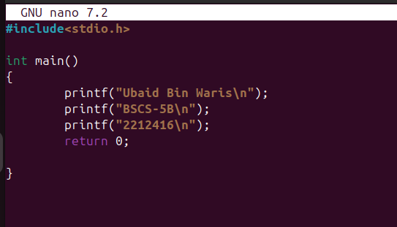

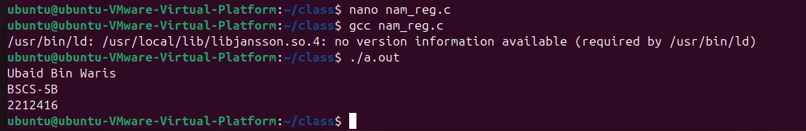

**Q2: Write a C code to print your first name once and last name 10 times using fork(). Also print Parent and Child Process ID.**

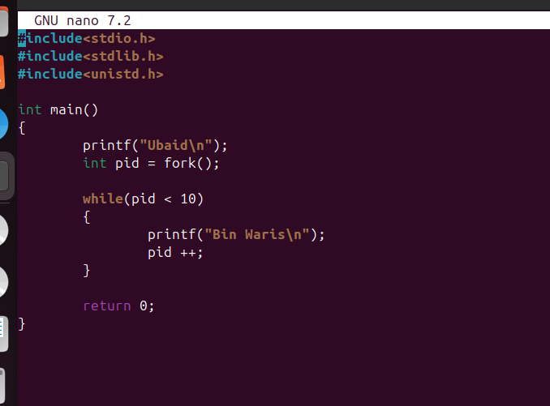

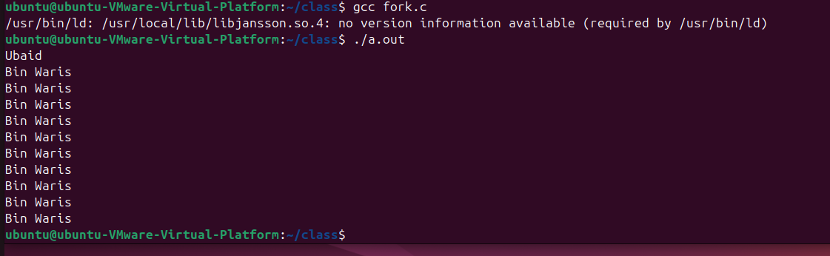

**Q3: Write a C program where:**

* The parent process prints "Parent: My name is [Your Full Name]".
* The child process prints "Child: Hello from [Your First Name]!" and exits with a status equal to the length of your first name.
* The parent process should wait for the child and then print "Child exited with status X", where X is the child's exit status.

**Commands to Compile Code:**

gcc filename.c -o filename

./filename

**Note:** Must attach screenshots of your output screen

